Design Document

MDW

Do you want to be a millionaire? (Group 5)

Yidi Wu

Iulian Toma  
Ji Nan

Contents

Architecture Diagram 1

Description of Interfaces 1

1. Add Crossing 1

2. Remove Crossing 2

Class Diagram for Client 3

Class Diagram for Service 3

Sequence Diagram 4

1. Ask a Question 4

2. Ready to Play 4

**Architecture Diagram**

IGameplayCallback

IGameplay

Gameplayserver

Gameplayclient1

Gameplayclient2

**Description of Interfaces**

|  |
| --- |
| **<<interface>> IGamePlay** |
|  |
| + void ConfirmAnswer(string a)  + void CorrectAnswer()  + bool CheckAnswer(string a) |

|  |
| --- |
| **<<interface>>IGamePlayCallback** |
|  |
| + void PlayerTurn()  + void PlayerReady()  + void ShowNextQuestion(Player p)  + void ShowResult() |

**Class Diagram for Client**

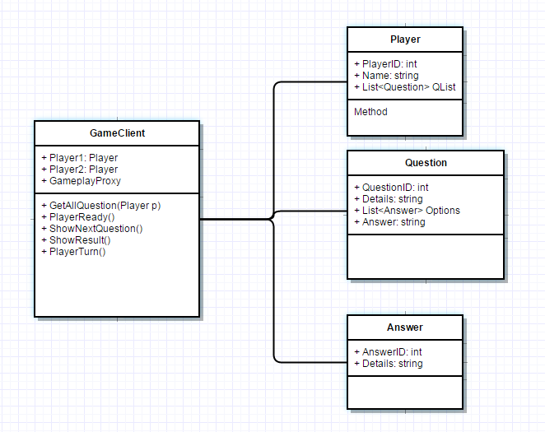

**Class Diagram for Service**

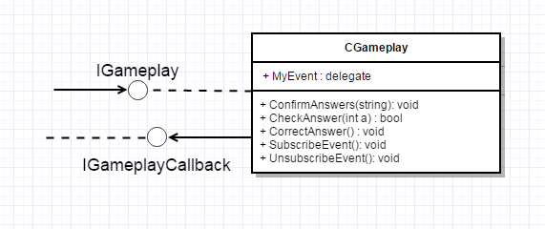

**Sequence Diagram**

1. **Ask a Question**



1. **Ready to Play**

